iVoteCatholic
Sample Intentions for the Universal Prayer

In addition to the usual intentions for the local community, please consider the following which correspond to both the readings of the day and the Catholic Social Teaching theme.
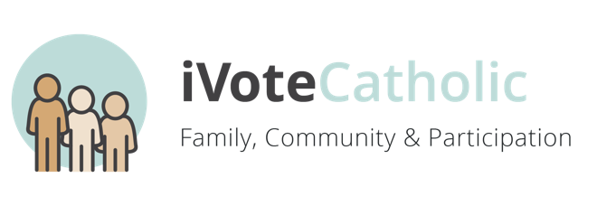
WEEK 1
Family, Communication, & Participation

For our families and communities: may we be people of mercy and forgiveness…

For parents and their children: may we learn compassion and kindness from Jesus…

For elected officials: may they ensure the rights of prisoners…

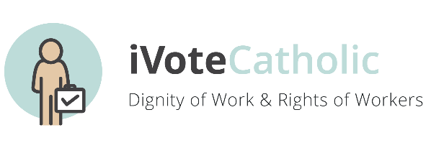
WEEK 2
Dignity of Work & Rights of Workers

For a greater respect for the dignity of work and the rights of workers…

For employers: may they foster workplaces of dignity and respect…

For governments all over the world: may they uphold the common good and ensure a decent wage for those who labor…

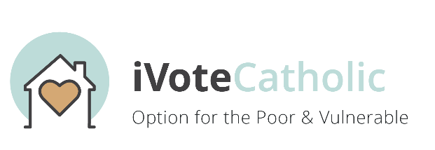
WEEK 3
Option for the Poor and Vulnerable

For the poor: may they know they too are heirs to the treasures of heaven…

For leaders of cities, states, and nations: may they work for the common good, upholding the dignity of the poor and vulnerable…

For our faith community: may we work to serve the poor and most vulnerable people in our midst…

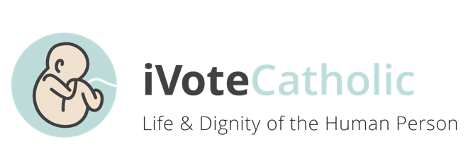
WEEK 4
Life & Dignity of the Human Person

For governmental leaders: may they create laws and policies that uphold the dignity of every human life…

For all those who struggle with their own self-worth: may they know their own intrinsic value as a child of God…

For an end to wars and violence…

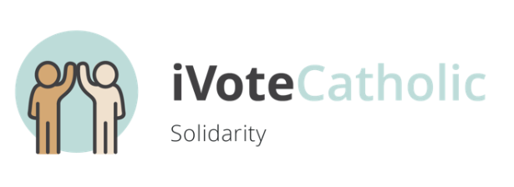

WEEK 5
Solidarity

For all members of the Church: may we answer the call to serve one another…

For our parish community: may we grow in solidarity with all those who follow Christ…

For those discerning their vocation: may they find solidarity with the Church…

For leaders of cities, states, and nations: may they always work to promote the common good and human flourishing…
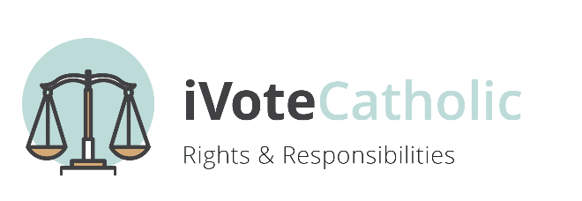
WEEK 6
Rights & Responsibilities

For our parish community: may we be greater stewards of our resources to build up the kingdom of God…

For all elected leaders: may they be more responsible to their communities and seek the good of all…

For all of us: may we always conform our will more closely to God’s will…

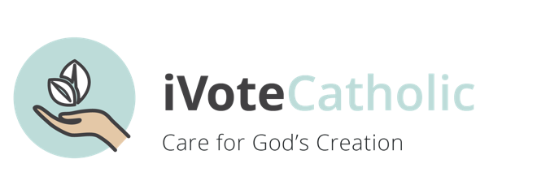

WEEK 7
Care for Creation

For a greater stewardship of the riches of the earth…

For those who serve in public office: may they promote laws and policies which protect the beauty of God’s creation…

For ourselves: that we may love our neighbor, our land, and all of God’s gifts as we love ourselves…

