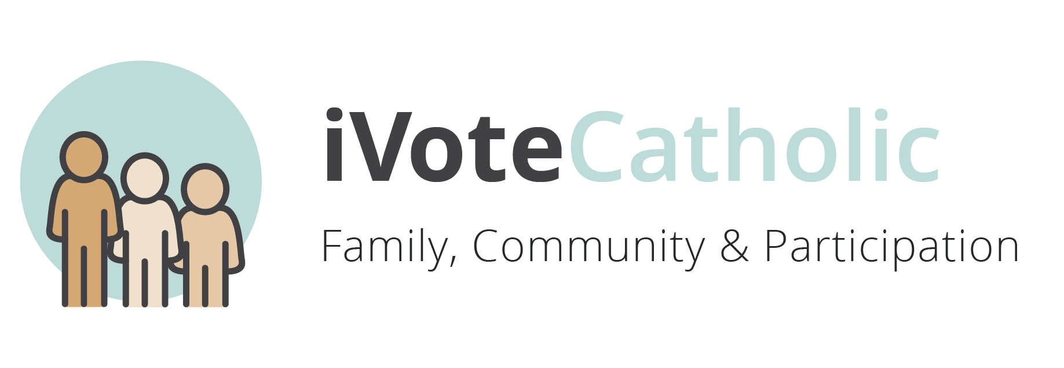
Week 1: Family, Community and Participation
The person is not only sacred but also social. Family must be supported, and people have a right & duty to participate in society for social problems are best addressed by community networks.
The family forms people in love and remains open to the community, moved by a sense of justice and concern for others. St John Paul II, Familiaris Consortio, no.64
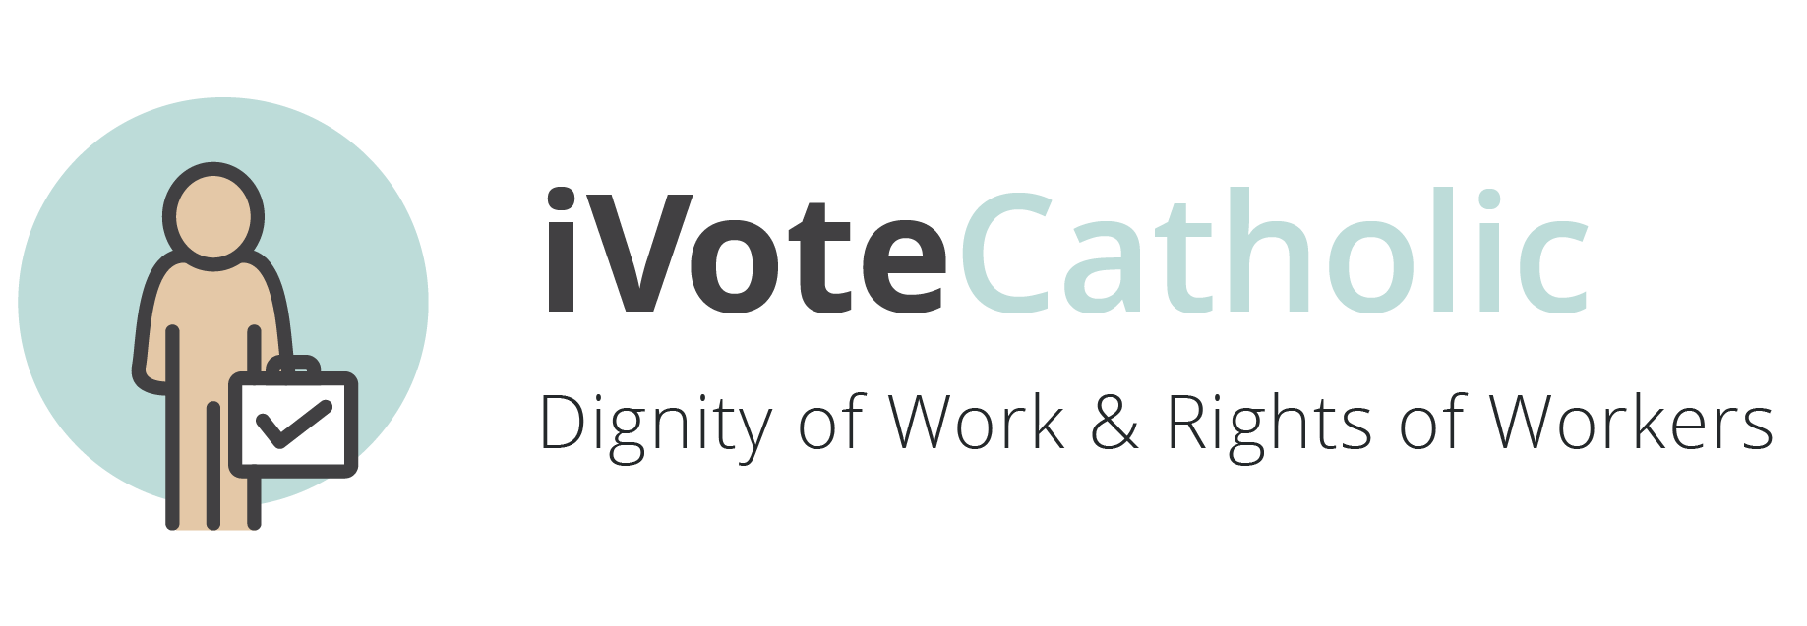
Week 2: Dignity of Work & Rights of Workers
Work is more than a way to make a living; it is a form of continuing participation in God’s creation.
…work is of fundamental importance to the fulfillment of the human being and to the development of society. Pope Benedict XVI, Apostolic Exhortation on the Eucharist, 2007 no. 74
The obligation to earn one's bread by the sweat of one's brow also presumes the right to do so. St. John Paul II, Centesimus Annus, no. 43
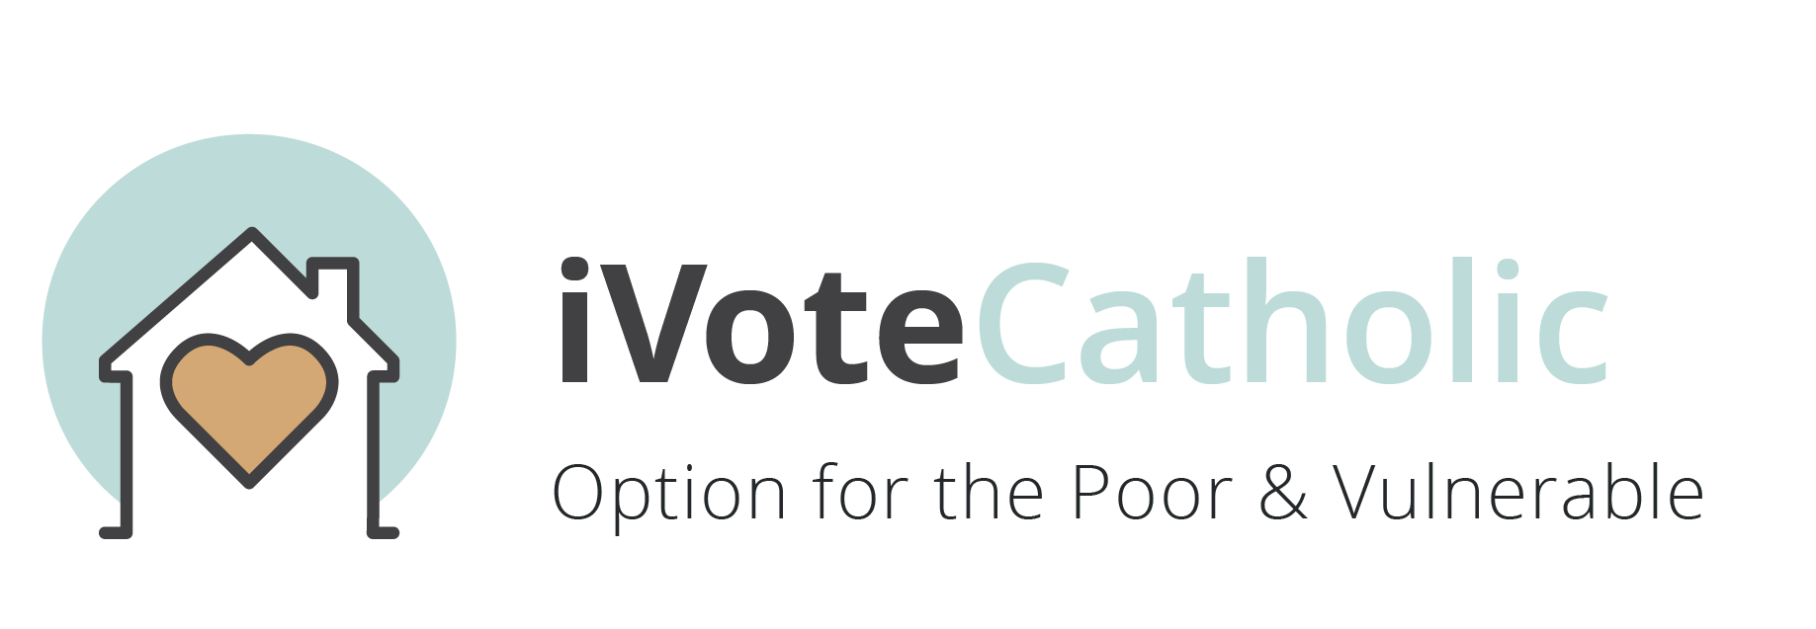
_______________________________________________________________________________________
Week 3: Option for the Poor & Vulnerable
The Church does not pit one social group against another but instead follows the example of Jesus, who identified with the poor and vulnerable.
The prime purpose of this special commitment to the poor is to enable all persons to share in and contribute to the common good.
Those who are oppressed by poverty are the object of a preferential love on the part of the Church which, since her origin and in spite of the failings by many of her members, has not ceased to work for their relief, defense and liberation.” Catechism of the Catholic Church nos. 2444, 2448 (quoting St John Paul II, Centisimus Annus, no. 57)
The "option for the poor," therefore, is not an adversarial slogan that pits one group or class against another. Rather it states that the deprivation and powerlessness of the poor wounds the whole community. The extent of their suffering is a measure of how far we are from being a true community of persons.” The United States Catholic Conference of Bishops, Economic Justice for All, no. 88

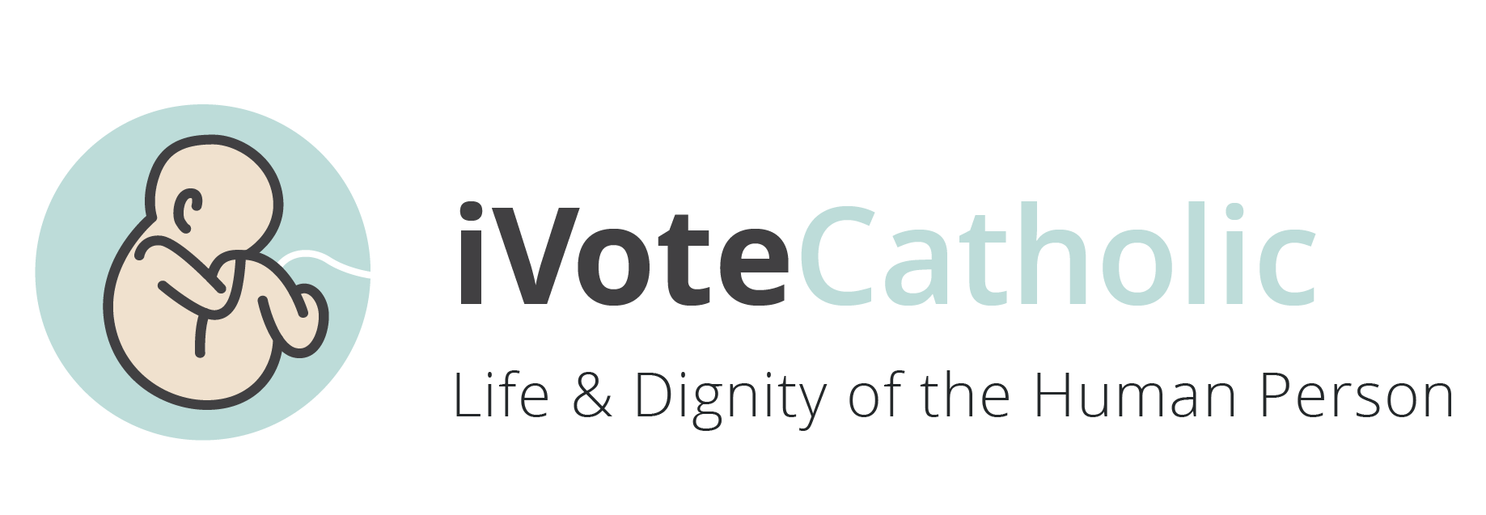
Week 4: Life & Dignity of the Human Person
As a gift from God, every human life is sacred from conception to natural death. The life and dignity of every person must be respected and protected at every stage and in every condition.
Human life, as a gift of God, is sacred and inviolable.
Not only must human life not be taken, but it must be protected with loving concern.
Society as a whole must respect, defend and promote the dignity of the human person, at every moment and in every condition of that person’s life. St John Paul II, Evangelium Vitae, no. 81
We believe that every person is precious, that people are more important than things, and that the measure of every institution is whether it threatens or enhances the life and dignity of the human person.
Every economic decision and institution must be judged in light of whether it protects or undermines the life and dignity of the human person. The United States Catholic Conference of Bishops, Economic Justice for All, no. 13

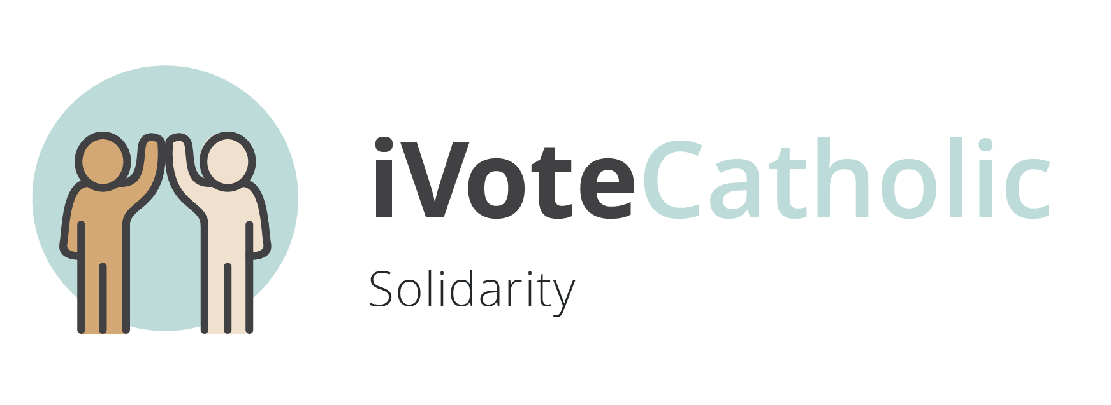
Week 5: Solidarity
We are one human family whatever our national, racial, ethnic, economic, and ideological differences.
Our love for all our sisters and brothers demands that we promote peace in a world surrounded by violence and conflict.
Solidarity helps us to see the ‘other’ – whether a person, people or nation – not just as some kind of instrument, with a work capacity and physical strength to be exploited at low cost and then discarded when no longer useful, but as our ‘neighbor’, a ‘helper’, to be made a sharer, on a par with ourselves. St. John Paul II, Sollicitudo Rei Socialis, no. 39
To love someone is to desire that person's good and to take effective steps to secure it… To desire the common good and strive towards it is a requirement of justice and charity. Pope Benedict XVI, Caritas in Veritate, no. 7

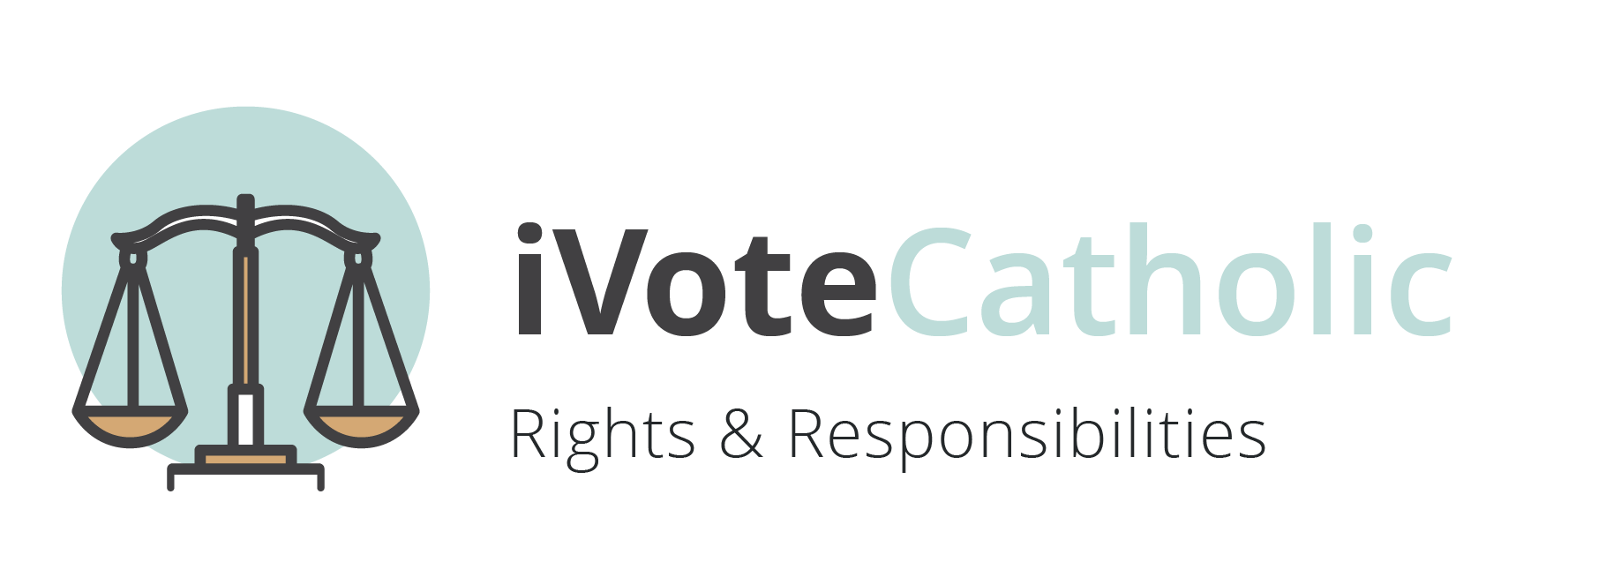
Week 6: Rights and Responsibilities

Therefore every person has a fundamental right to life and a right to those things required for human decency. Corresponding to these rights are duties and responsibilities – to one another, to our families and to the larger society.

Every basic human right draws its authoritative force from the natural law, which confers it and attaches to it its respective duty. Hence, to claim one’s right and ignore one’s duties, or only half fulfill them, is like building a house with one hand and tearing it down with another. St. John XXIII, Pacem in Terris, no. 30

With rights come responsibilities to others, to our families and to the common good of all.

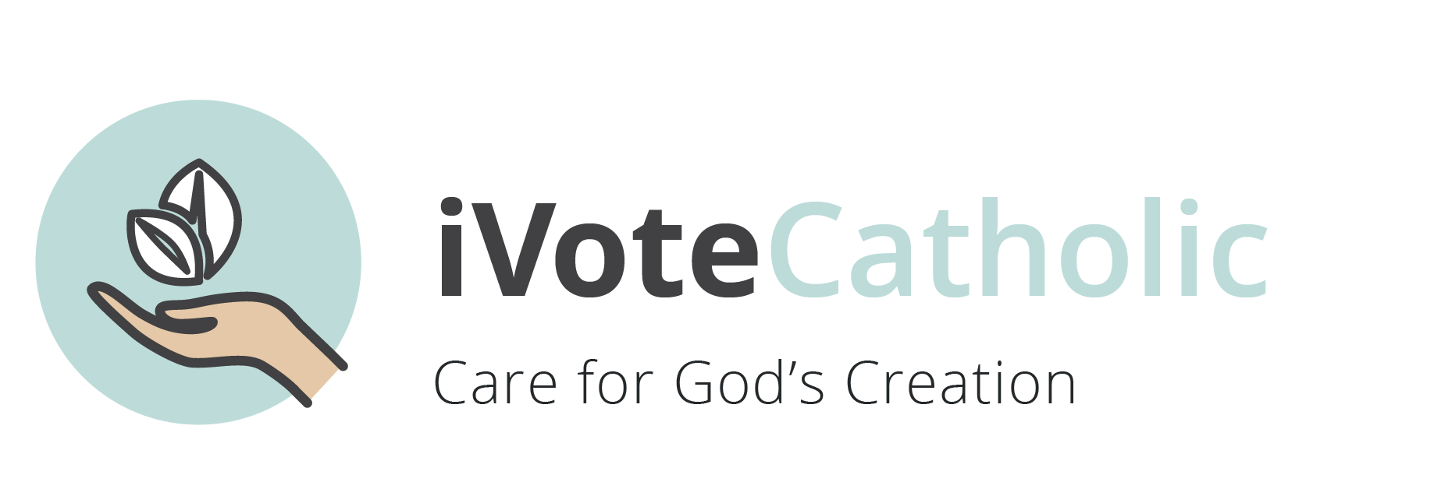
Week 7: Care for Creation

We are called to protect people and the planet, living our faith in relationship with all of God’s creation. This environmental challenge has fundamental moral and ethical dimensions that direct us to an integral ecology that demands care for the earth and care for the most vulnerable among us.

Respect for life and for the dignity of the human person extends also to the rest of creation, which is called to join man in praising God. St. John Paul II, January 1990 Peace with God the Creator, Peace with All Creation, no. 16

“We human beings are united as brothers and sisters on a wonderful pilgrimage woven together by the love God has for each one of his creatures.” Pope Francis, Laudato Si, nos. 92,93

