iVoteCatholic Hymn/Song Text Suggestions

WEEK 1
Sept 13
24th Sunday in Ordinary Time
Family, Communication, & Participation
http://usccb.org/bible/readings/091320.cfm

Diverse in Culture, Nation, Race Duck GIA
A Place At The Table Alonso GIA
When We Are Living Escamilla WLP
Where Charity and Love Prevail Benoit Various
The Master Came to Bring Good News Finn GIA
The Reign of God Dufner GIA
Forgive Our Sins, As We Forgive Herklots Various
For the Beauty of the Earth Pierpont Various
God is Here! As We His People Green Hope
The Church of Christ in Every Age Green Hope
Ubi Caritas Traditional Various

WEEK 2
Sept 20
25th Sunday in Ordinary Time
Dignity of Work & Rights of Workers
http://usccb.org/bible/readings/092020.cfm

Called to Labor in God’s Vineyard Chepponis GIA
Christ is Made the Sure Foundation Neale Various
For the Fruits of All Creation Green Hope
God Whose Giving Knows No Ending Edwards Hope
God Our Father You Have Granted Stuempfle GIA
Lord of All Hopefulness Struther Oxford/GIA
The Master Came to Bring Good News Finn GIA
God Of Our Salvation Norbet WLP
Those Who Love and Those Who Labor Dearmer Oxford/OCP

WEEK 3
Sept 27
26th Sunday in Ordinary Time
Option for the Poor and Vulnerable
http://usccb.org/bible/readings/092720.cfm

The Lord Hears the Cry of the Poor Foley OCP
To the Poor a Lasting Treasure O’Brien GIA
My Elder Son, Go Work Today! Whitney Selah/GIA
God, Your Knowing Eye Can See Tice GIA
The Church of Christ, In Every Age Green Hope
Lord, When You Came to the Seashore Gabarain OCP
The Love of Christ Urges Us On Honore WLP
O God of Love Baker WLP
Abundant Life Haugen GIA

WEEK 4
Oct 4
27th Sunday in Ordinary Time
Life & Dignity of the Human Person
http://usccb.org/bible/readings/100420.cfm

In the Lord I’ll Be Ever Thankful Taize GIA
The Keeper of a Vineyard Hudson Church/GIA
Christ is the World’s Light Green Hope
Let All Things Now Living Davis Schirmer
Praise to the Lord, the Almighty Neander Various
Joyful, Joyful, We Adore You Van Dyke Various

WEEK 5
Oct 11
28th Sunday in Ordinary Time
Solidarity
http://usccb.org/bible/readings/101120.cfm

Come to the Feast Moore GIA
My Shepherd, You Supply My Need Watts Various
Diverse in Culture, Nation, Race Duck GIA
In Christ There is No East or West Dunkerley Various
Christ, You Formed the Church,
Your Body Stuempfle GIA
Not Alone, But Two by Two Daw Hope
Risen Lord, We Gather Round You Stuempfle GIA
There is One Lord Taize GIA

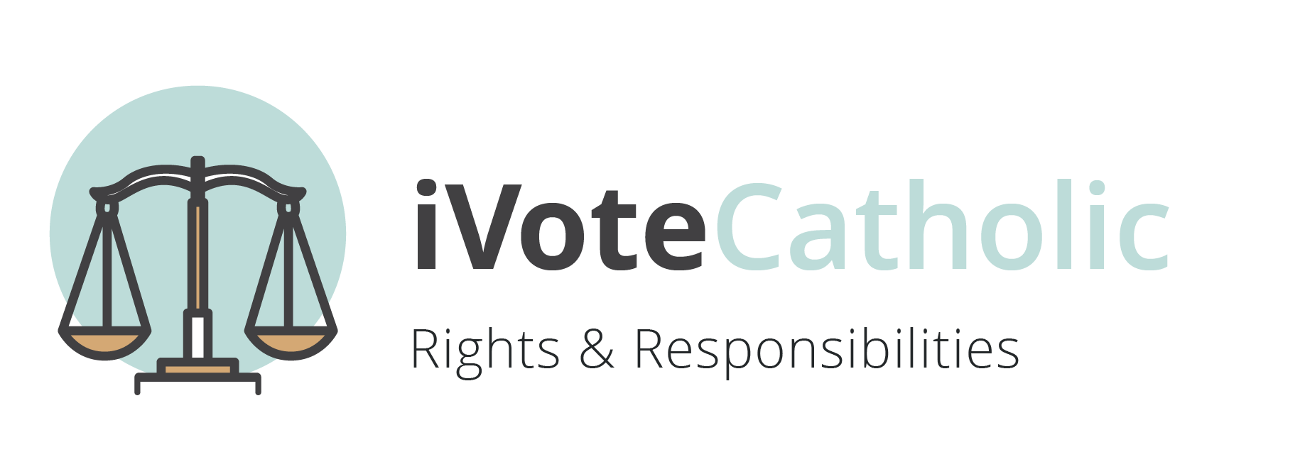
WEEK 6
Oct 18
29th Sunday in Ordinary Time
Rights & Responsibilities
http://usccb.org/bible/readings/101820.cfm

No Greater Love Joncas GIA
The Church of Christ, In Every Age Green Hope
When Jesus Came
Preaching the Kingdom of God Green Hope
Called to Labor in God’s Vineyard Chepponis GIA
Angels, Saints, and Holy Ones Marchionda WLP
Seek Ye First Maranatha Various
Go, Make of All Disciples Adkins Various

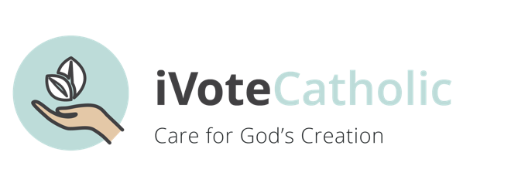
WEEK 7
Oct 25
30th Sunday in Ordinary Time
Care for Creation
http://usccb.org/bible/readings/102520.cfm

For the Beauty of the Earth Pierpont Various
For the Fruits of All Creation Green Hope
For the Healing of the Nations Kaan Hope
God, We Praise You! (Te Deum) Idle Hope
How Great Thou Art Hine Hope
Joyful, Joyful, We Adore You Van Dyke Various
Let All Things Now Living Davis Schirmer
Come, Christians, Join to Sing Bateman Various
God Beyond All Names Farrell OCP
Morning Has Broken Farjeon Various
Word of God, You Spoke Creation Glen OCP
The Word of God Was From the Start Troeger Oxford/OCP

