iVoteCatholic
Sample Intentions for the Universal Prayer

In addition to the usual intentions for the local community, please consider the following which correspond to both the readings of the day and the Catholic Social Teaching theme.

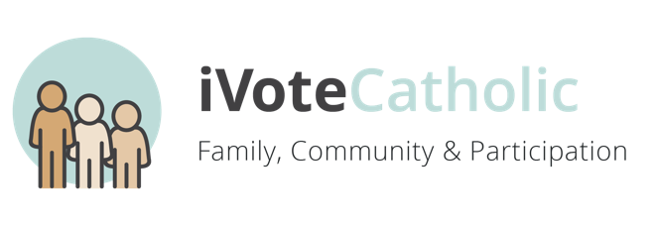
WEEK 1
Sept 13
24th Sunday in Ordinary Time
Family, Communication, & Participation
http://usccb.org/bible/readings/091320.cfm

For our families and communities: may we be people of mercy and forgiveness…

For parents and their children: may we learn compassion and kindness from Jesus…

For elected officials: may they ensure the rights of prisoners…

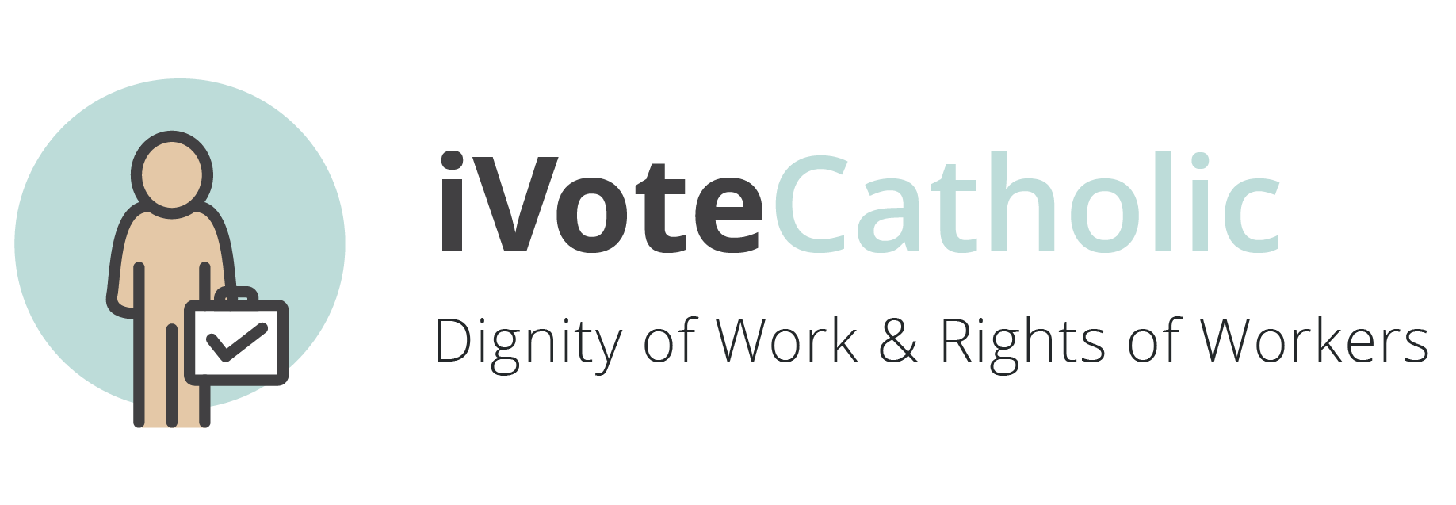
WEEK 2
Sept 20
25th Sunday in Ordinary Time
Dignity of Work & Rights of Workers
http://usccb.org/bible/readings/092020.cfm

For a greater respect for the dignity of work and the rights of workers…

For employers: may they foster workplaces of dignity and respect…

For governments all over the world: may they uphold the common good and ensure a decent wage for those who labor…

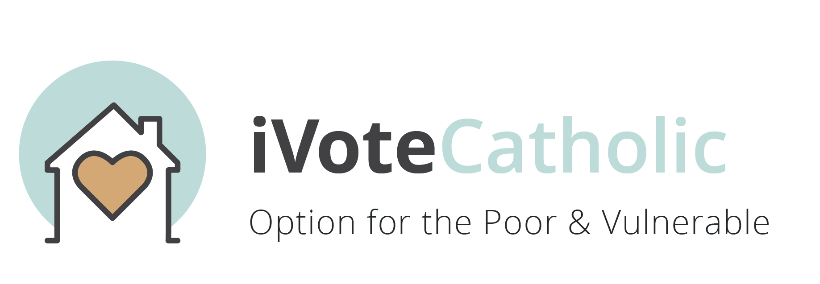
WEEK 3
Sept 27
26th Sunday in Ordinary Time
Option for the Poor and Vulnerable
http://usccb.org/bible/readings/092720.cfm

For the poor: may they know they too are heirs to the treasures of heaven…

For leaders of cities, states, and nations: may they work for the common good, upholding the dignity of the poor and vulnerable…

For our faith community: may we work to serve the poor and most vulnerable people in our midst…

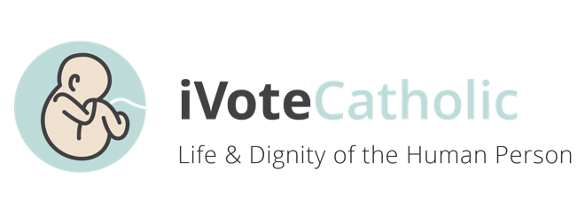
WEEK 4
Oct 4
27th Sunday in Ordinary Time
Life & Dignity of the Human Person
http://usccb.org/bible/readings/100420.cfm

For governmental leaders: may they create laws and policies that uphold the dignity of every human life…

For all those who struggle with their own self-worth: may they know their own intrinsic value as a child of God…

For an end to wars and violence…

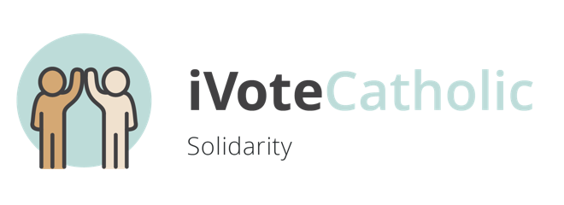
WEEK 5
Oct 11
28th Sunday in Ordinary Time
Solidarity
http://usccb.org/bible/readings/101120.cfm

For all members of the Church: may we answer the call to serve one another…

For our parish community: may we grow in solidarity with all those who follow Christ…

For those discerning their vocation: may they find solidarity with the Church…

For leaders of cities, states, and nations: may they always work to promote the common good and human flourishing…

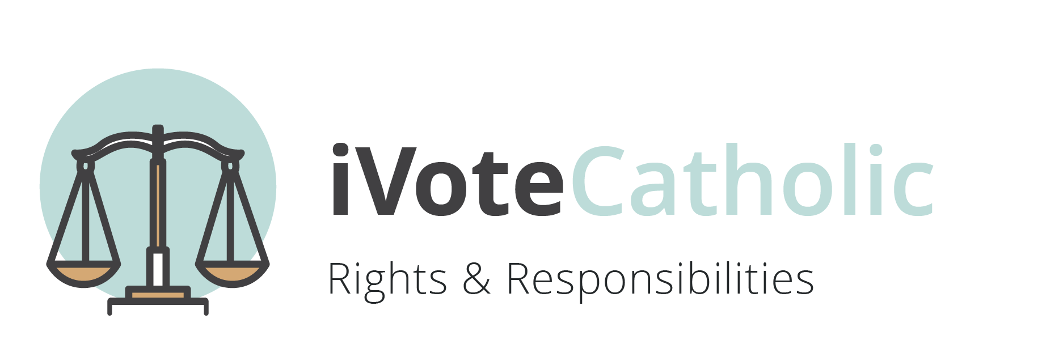
WEEK 6
Oct 18
29th Sunday in Ordinary Time
Rights & Responsibilities
http://usccb.org/bible/readings/101820.cfm

For our parish community: may we be greater stewards of our resources to build up the kingdom of God…

For all elected leaders: may they be more responsible to their communities and seek the good of all…

For all of us: may we always conform our will more closely to God’s will…

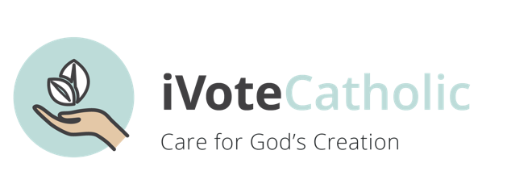
WEEK 7
Oct 25
30th Sunday in Ordinary Time
Care for Creation
http://usccb.org/bible/readings/102520.cfm

For a greater stewardship of the riches of the earth…

For those who serve in public office: may they promote laws and policies which protect the beauty of God’s creation…

For ourselves: that we may love our neighbor, our land, and all of God’s gifts as we love ourselves…

