Bulletin Notices

9/6/2020: Introduction

iVoteCatholic: We are called to live our faith in all aspects of our lives. This provoking question requires much prayer and discernment from each of us. We acknowledge the difficulty of this question and the perceived alignment or misalignment of the candidates and issues with our Catholic faith. Our Church teaches a consistent ethic of life so we are called to be advocates for a variety of issues related to life and human dignity. Some have misinterpreted this teaching to convey that each related issue is morally equivalent. This is not the case. Some have misinterpreted this teaching to convey that one related issue could excuse indifference to the rest: this is not the case either. We have challenging work ahead of us! Starting next week, the Archdiocese of Cincinnati will be offering prayers, scripture, quotes, family activities and discerning questions through the lens of the seven principles of Catholic Social Teaching to aid the discerning vote. We will not be telling you for whom or what to vote. We will be encouraging careful discernment, intentional prayer, and a universal call to holiness and compassion to inform your voting. Find out more at www.iVoteCatholic.org.

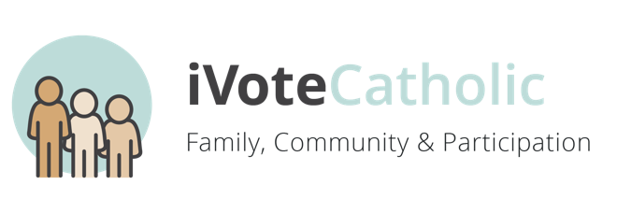
9/13/2020: Family, Community, and Participation

iVoteCatholic: During this first week, we focus on the call to Family, Community and Participation. Our God is Trinity, three persons, one God. These three persons are in constant relationship with each other. Being created in the image of God, we too need to be in relationships. Each human person is not only sacred but also social. We must recognize and cherish the gift of belonging to our immediate family and wider family; the Church and society. The Church teaches that in order to fully belong to a family and community, participation is essential. We encourage you to ensure you and your family are registered to vote. Get informed and educated about the candidates and issues on the ballot. Our community calls us to participate not just for our own needs but for the larger whole of society. Voting is an actionable way to love and a tool to cultivate community. Find out more at www.iVoteCatholic.org.

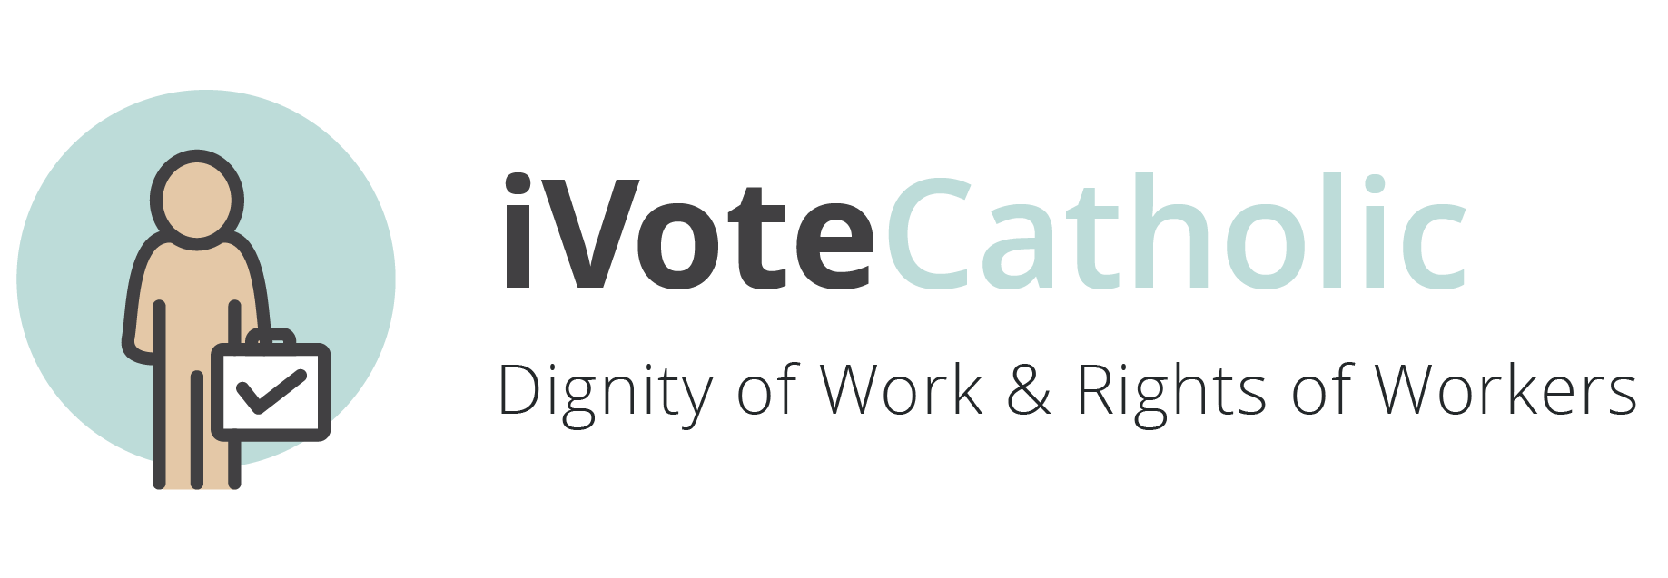
9/20/2020: Dignity of Work & Rights of Workers

iVoteCatholic: During this second week, we focus on the Dignity of Work and the Rights of Workers. In our Catholic tradition, work is more than just a way to make a living; work is one of the ways we participate in the ongoing work of creation in our world. Those who are responsible for the employment of people have a special responsibility to make decisions that uphold the dignity and safety of workers and their rights. Those rights include being able to earn fair wages, to have productive work, and to have a say in decisions that affect them, including the right to organize. Under this principle fall issues such as living wages, fair hiring practices, availability of job training/skills, discrepancy in employment for women and minorities, and job availability for thriving not just surviving. Find out more at www.iVoteCatholic.org.

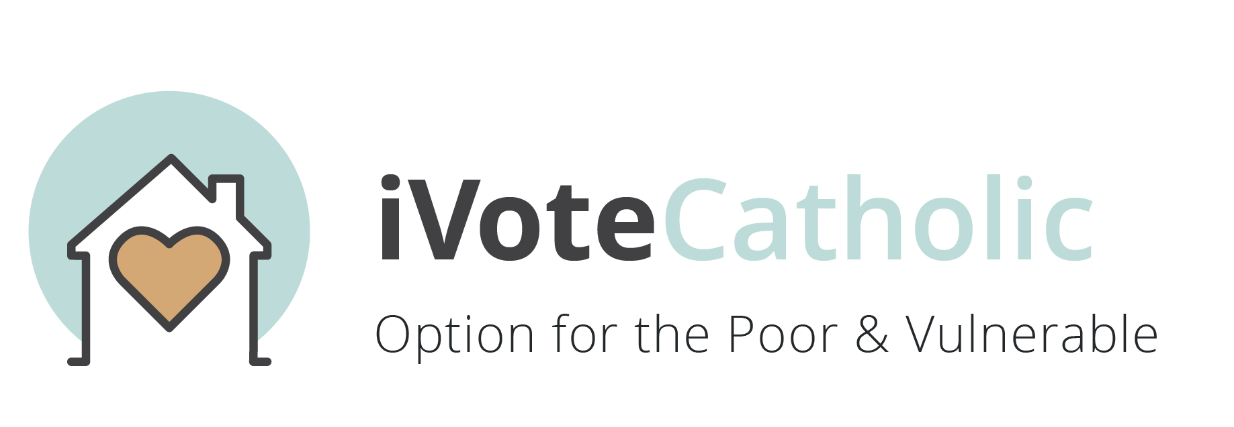
9/27/2020: Option for the Poor & Vulnerable

iVoteCatholic: During this third week, we focus on Option for the Poor and Vulnerable. “Lord, when did we see you hungry and feed you…” (Matt 25:31). Scripture reminds us that some people’s needs are so urgent and so great that their needs come first. Therefore, while everyone is important, those whose voice in our society is ignored, those whose human rights are violated, those whose dignity is not recognized, must take our first priority. When we enter into the lives and the struggles of the poor and vulnerable, we experience Jesus’ presence in a real and powerful way. We need to remember in this principle persons who are elderly, disabled, marginalized, vulnerable, formerly incarcerated or otherwise discriminated against or disadvantaged. Under this principle fall issues such as addiction, mental health, healthcare, and systems that perpetuate poverty. Find out more at www.iVoteCatholic.org.

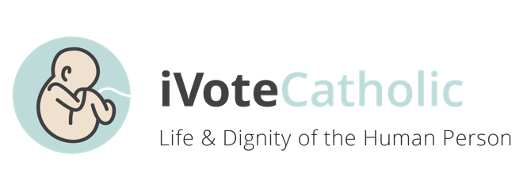
10/4/2020: Life & Dignity of the Human Person
iVoteCatholic: During this fourth week, we focus on the Life and Dignity of the Human Person which is also the focus of Respect Life Sunday. The Church teaches that we are all created in the image and likeness of God. Because of this fact, every human life is sacred. Every life is worth living. There is nothing anyone can do to take this dignity away. All of our Catholic social teaching flows from this principle. People are more important than things. Under this principle fall issues such as abortion, racism, war and terrorism, the death penalty, and assisted suicide. Find out more at www.iVoteCatholic.org.

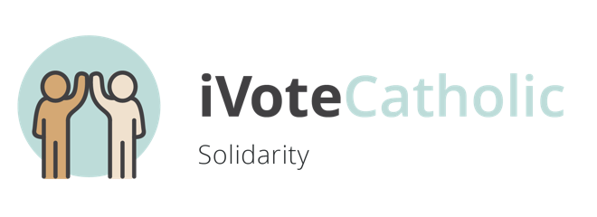
10/11/2020: Solidarity

iVoteCatholic: During this fifth week, we focus on Solidarity. We believe that every human person was created by the same God. Ultimately, we are all brothers and sisters. We are all connected. As one human family, we are deeply connected to people around the world—wherever they may be. Because we are one, we are affected by the joy and suffering of all. “If one member of Christ’s body suffers, all suffer. If one member is honored, all rejoice.” (1 Cor. 12:12–26). Living in solidarity means that we take action to make sure that every member of our human family is living in conditions that honor human dignity. Under this principle fall issues such as immigration, refugees, homelessness, foreign aid, global policy and empowerment, and religious freedom. Find out more at www.iVoteCatholic.org.

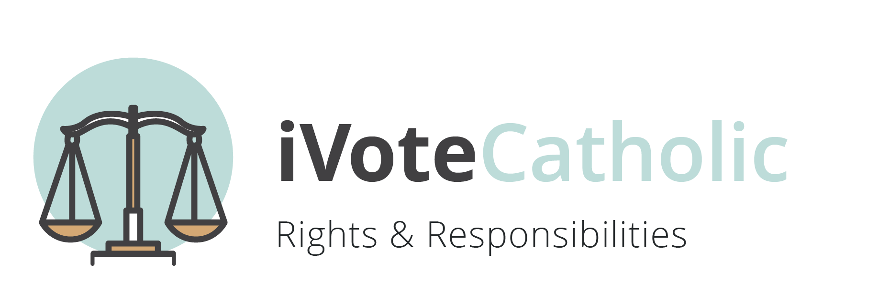
10/18/2020: Rights and Responsibilities

iVoteCatholic: During this sixth week, we focus on Rights and Responsibilities. Human beings, created in the image and likeness of God, have basic rights which protect our dignity and ensure all can live a full human life. Because these rights are universal, we have the responsibility to help maintain and protect these rights, not just for ourselves, but for all. Under this principle fall issues such as access to quality education, healthy food, healthcare, safe and affordable housing, and nonviolent neighborhoods. Find out more at www.iVoteCatholic.org.

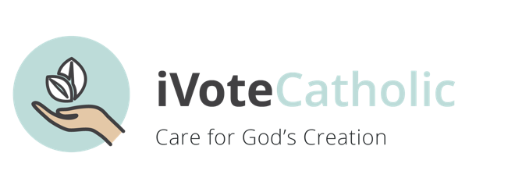
10/25/2020: Care for God’s Creation

iVoteCatholic: During this seventh week, we focus on Care for God’s Creation. Beginning with Pope St. John Paul II through Pope Francis, care for creation has been an integral part of Catholic social teaching. “Everything is connected. Concern for the environment thus needs to be joined to a sincere love of our fellow human beings and an unwavering commitment to resolving the problems of society…we human beings are united as brothers and sisters on a wonderful pilgrimage woven together by the love God has for each of his creatures.” (#92,93 Pope Francis) When we do things to protect the earth and care for it, we show reverence for God, the creator of all. Under this principle fall issues such as laws governing corporate and individual use of environmental resources - including land, water, and air - which impact all living things. Find out more at www.iVoteCatholic.org.

11/1/2020: Solemnity of all Saints

iVoteCatholic: Let us pray. All loving God, as the election approaches, we seek to better understand the wide-ranging issues and concerns that confront our city/state/country, and how the Gospel compels us to respond. We seek kindness, compassion and a loving heart while dialoguing with our family, friends, neighbors and community members who are also discerning their vote in this election. We ask for eyes that are free from blindness so that we might see each other as brothers and sisters, one and equal in dignity. We ask for ears that will hear the cries of all life. We ask for minds and hearts that are open to hearing the voices of leaders who will bring us closer to Your Kingdom. We pray for courage and generosity of spirit that we may choose leaders who hear Your Word, live Your love, and keep in the ways of Your truth. We desire You, compassionate God, to guide us to Your Kingdom of justice and peace. This we ask in the name of Your Son Jesus Christ, and through the power of the Holy Spirit. Amen. Find out more at www.iVoteCatholic.org.

*Bulletin Notices adapted from Sharing Catholic Social Teaching: Challenges and Directions.

